1. In Client 100 - Go to TCODE SALE

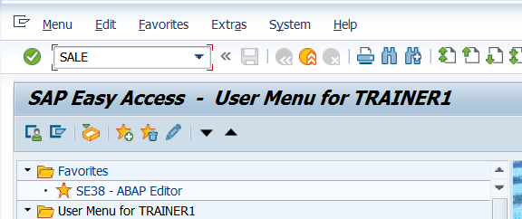

1. Expand Basic Settings->Logical Systems

Click on Execute on Define Logical Systems

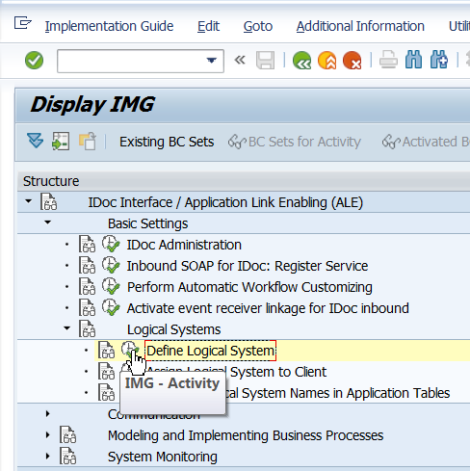

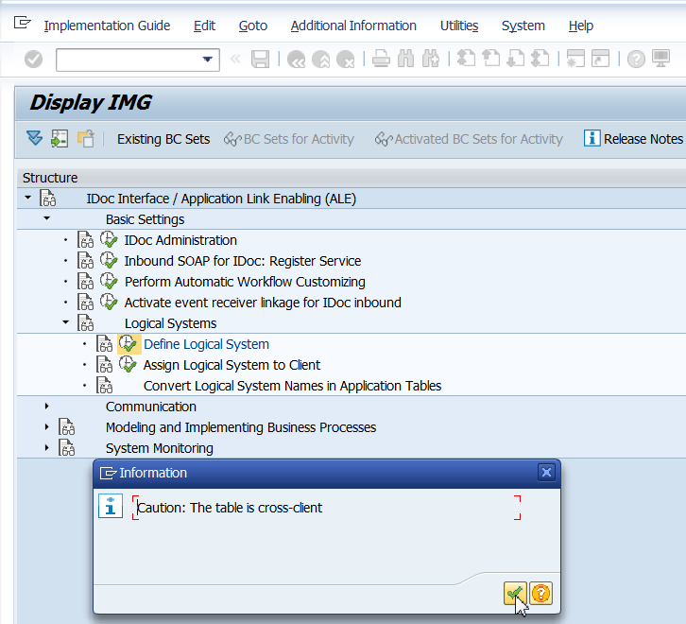

1. Observe the logical systems already created. New can be created by Clicking on New Entries.

**Note: DO NOT CREATE NEW ENTRIES**. Use the ones that have been created.

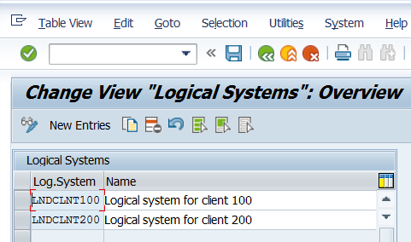

1. Logon on client 200 and verify that the same logical systems are also created in Client 200.

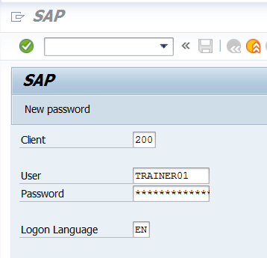

Go to TCODE SALE. Expand Basic Settings->Logical Systems

Click on Execute on Define Logical Systems

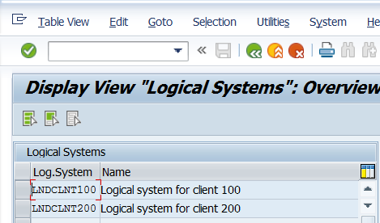

1. Client 100 – BD54. Opens the same screen as above. There is no need to go thru navigation from TCODE SALE.
2. Client 100 SCC4 –

**Note: No Changes to be done here.**

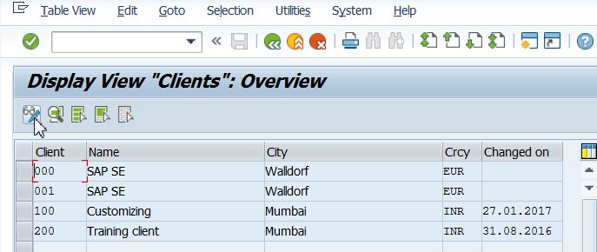

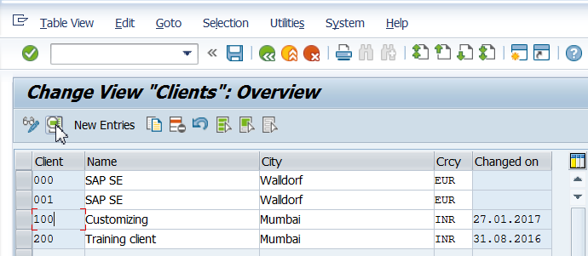

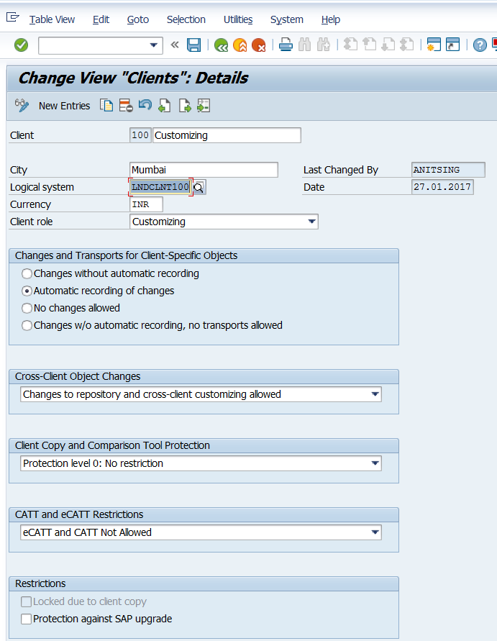

1. Client 200 – SCC4

**Note: No Changes to be done here.**

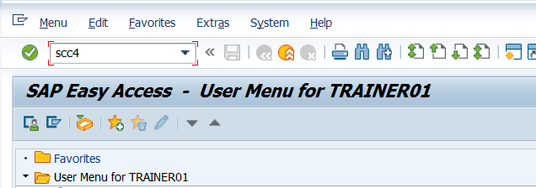

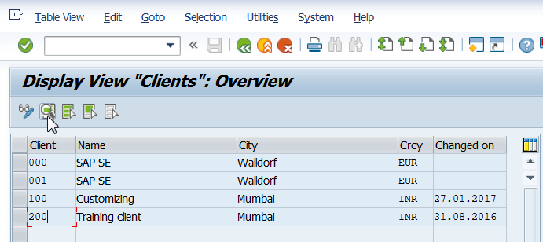

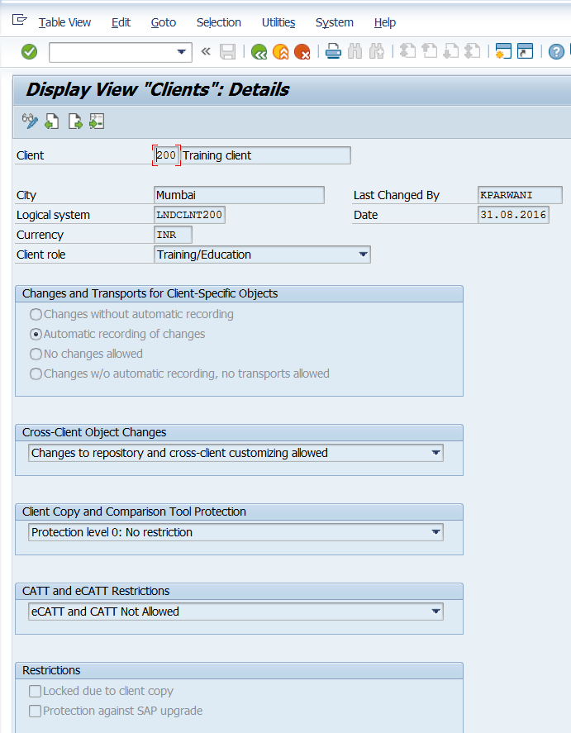

1. Create RFC connection on outbound side- Client 100. Refer to steps how to create RFC connection. These steps are not mentioned here.
2. Client 100 – WE21. Create port.

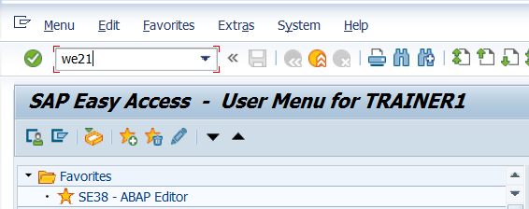

Place the cursor on Transactional RFC and click on create.

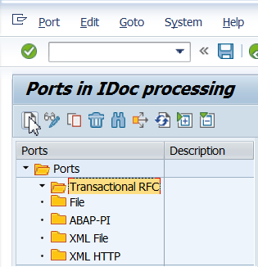

Click on the Radio Button own port name.

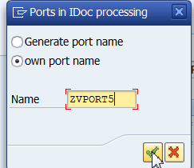

Save and go back.

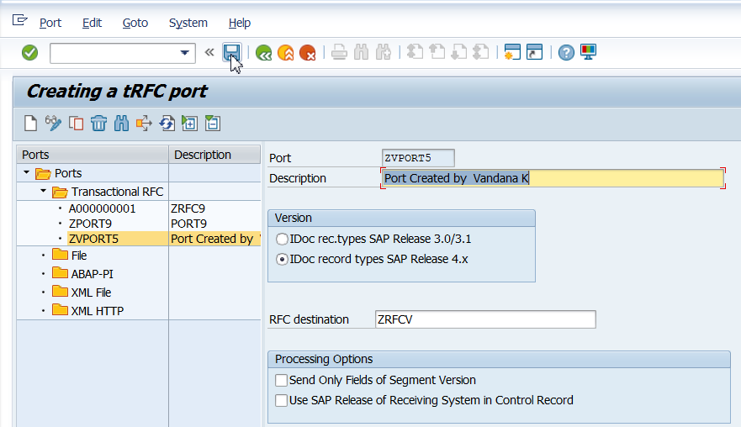

1. Client 100 – WE20. Create partner profiles.

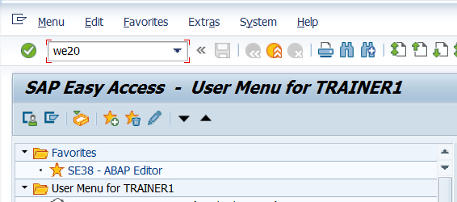

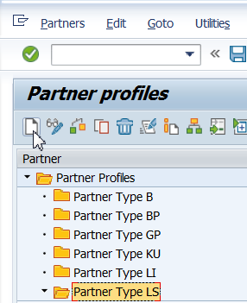

Enter details as shown below.

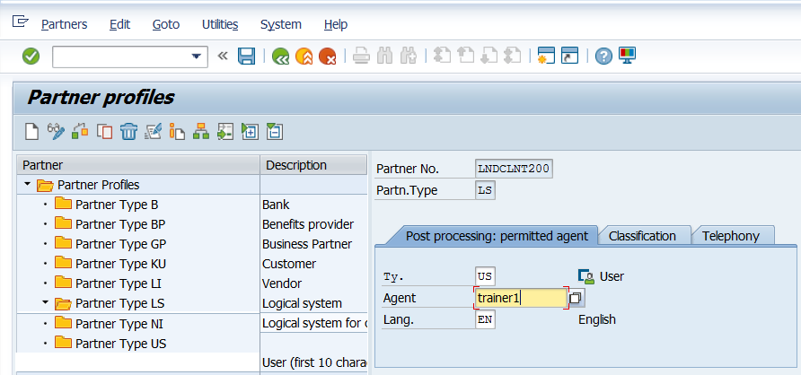

Press enter and save after you have entered the above details. The + for creating the outbound parameter will be visible only after you save the above details.

Create outbound parameter.

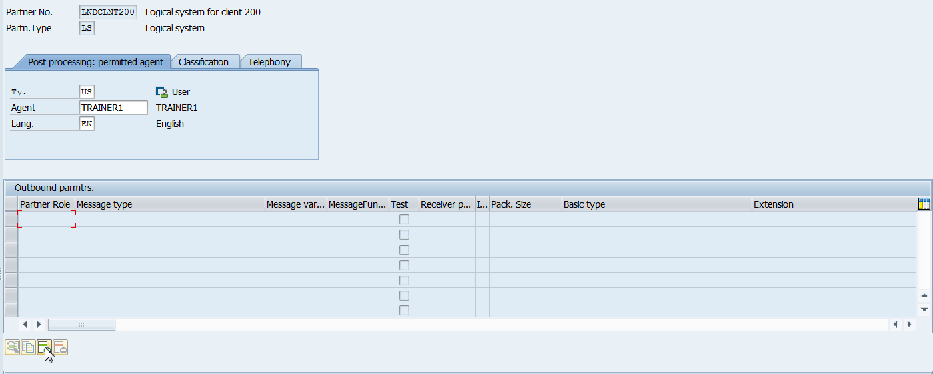

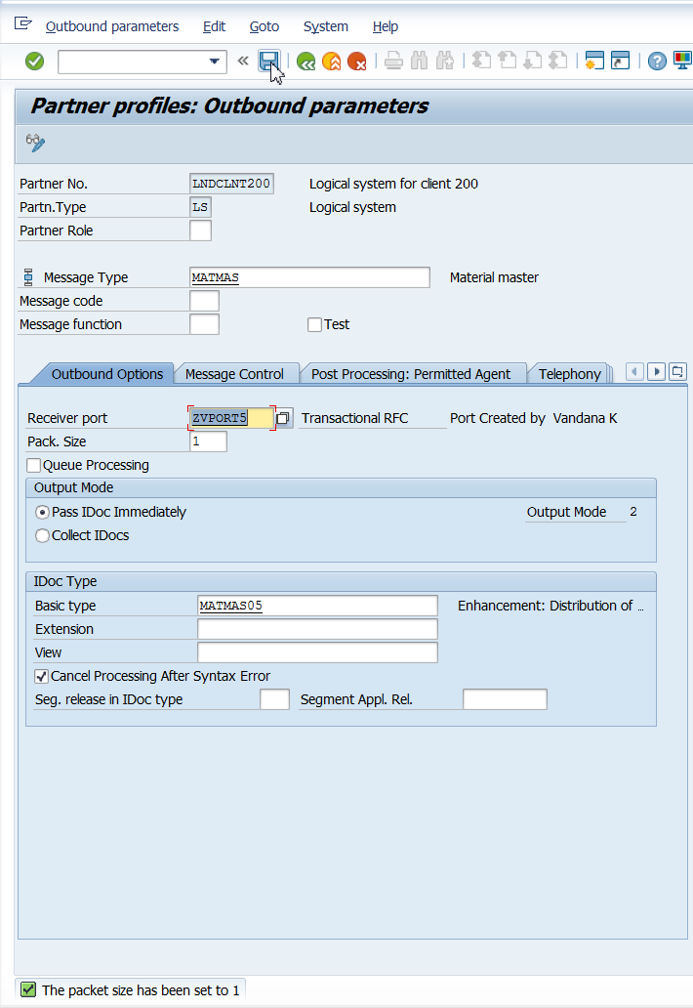

Save and go back.

1. Client 200- WE20. Create Inbound parameters here.

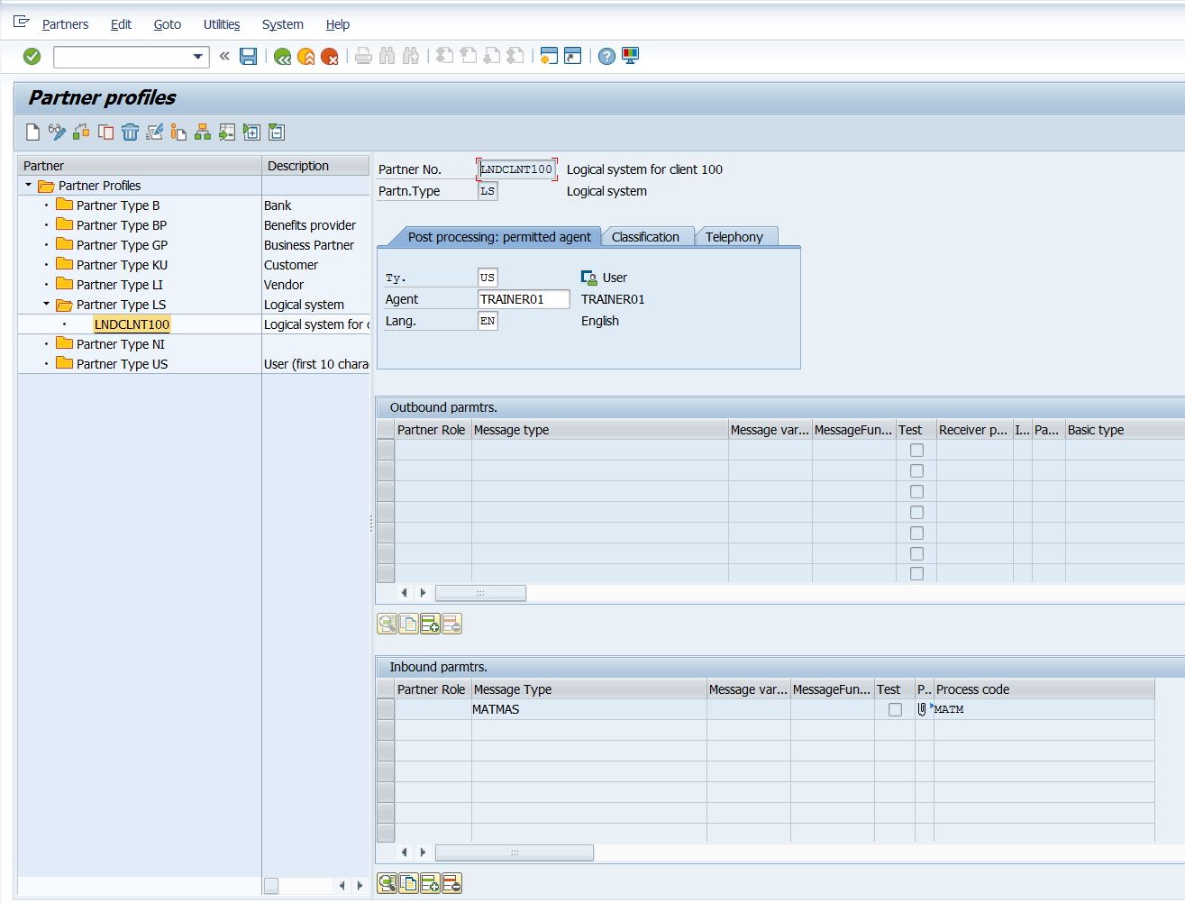

1. Client 100 – BD64

Click on Model Views – Create

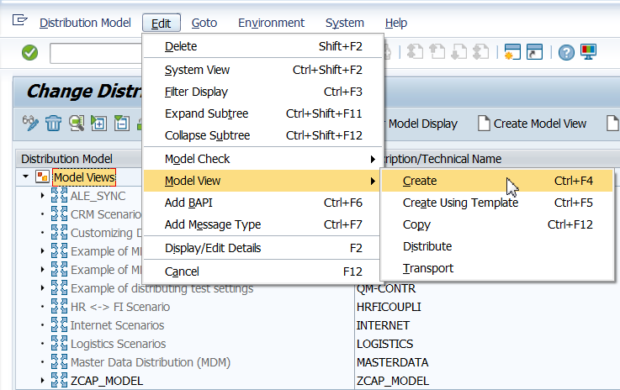

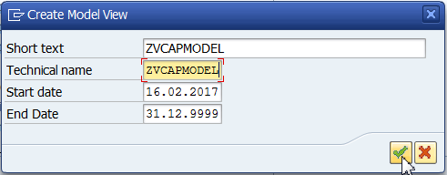

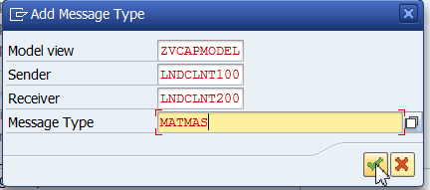

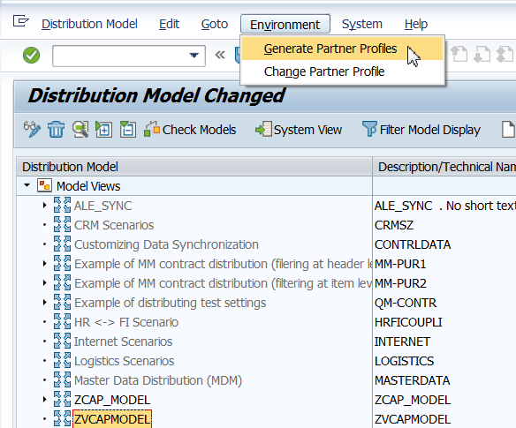

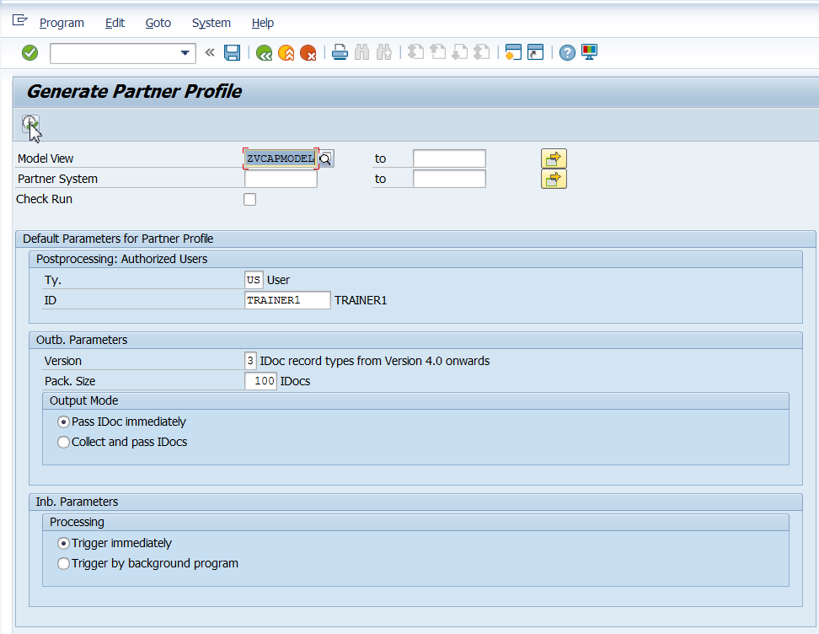

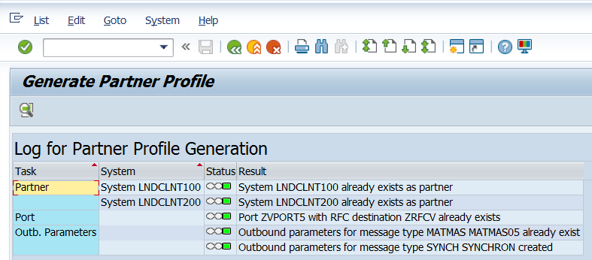

Save and press F3 till you come back to the screen below.

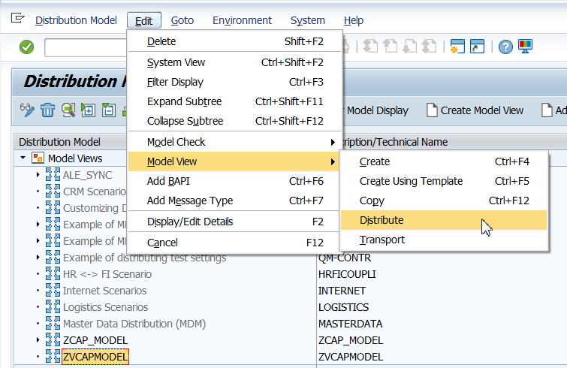

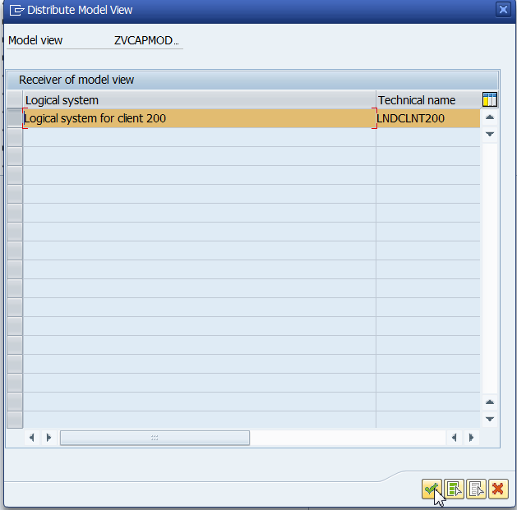

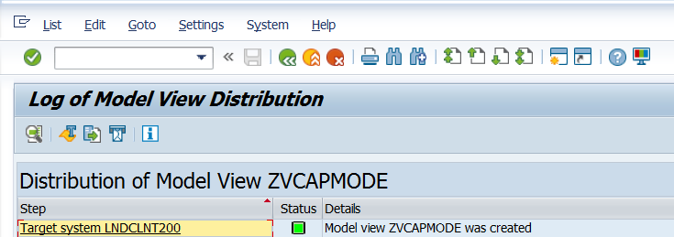

1. Client 100. Create a material using MM01. Add a few records.
2. Client 100 – BD10

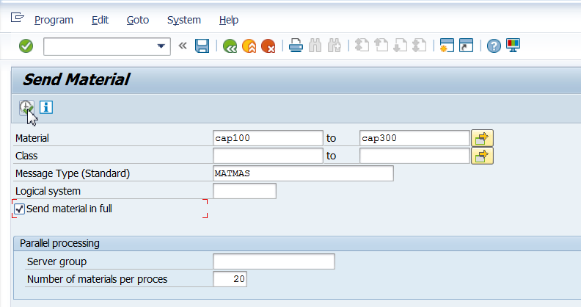

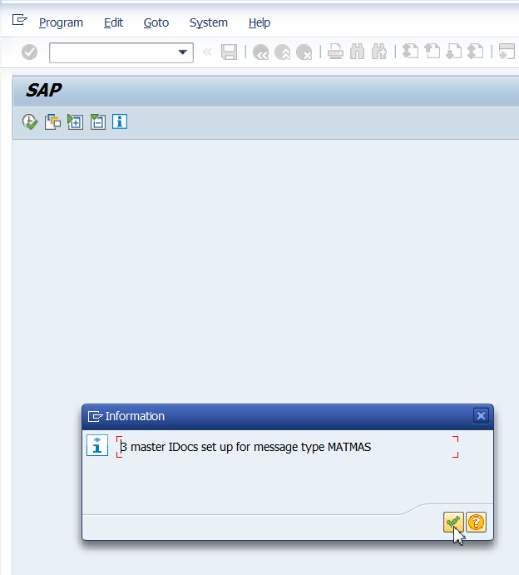

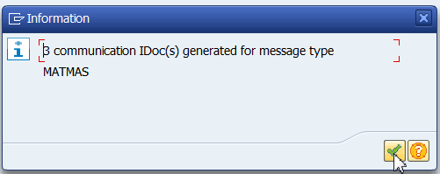

1. Client 100 WE02

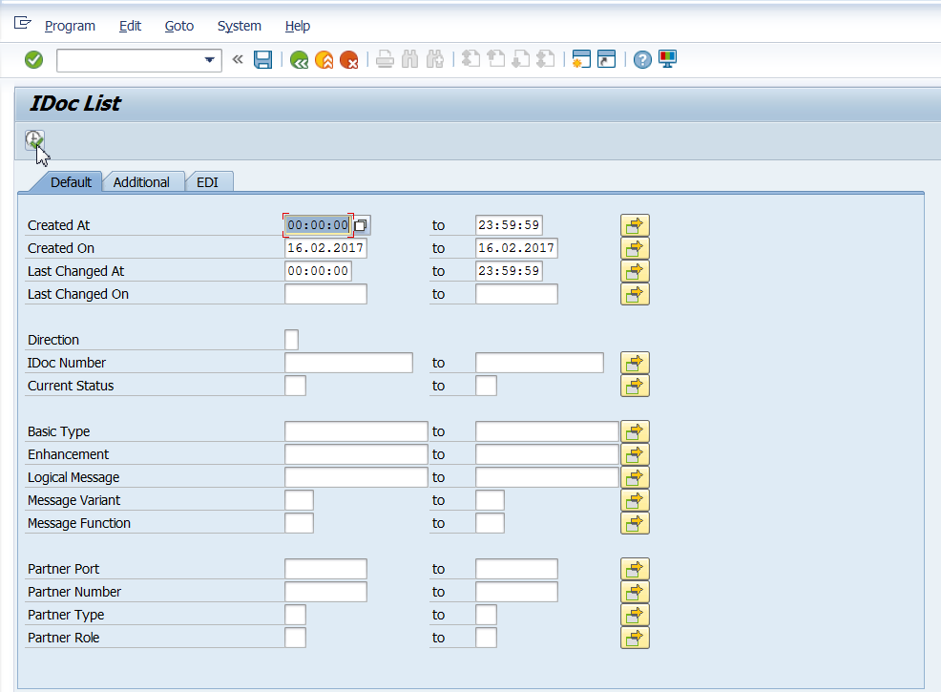

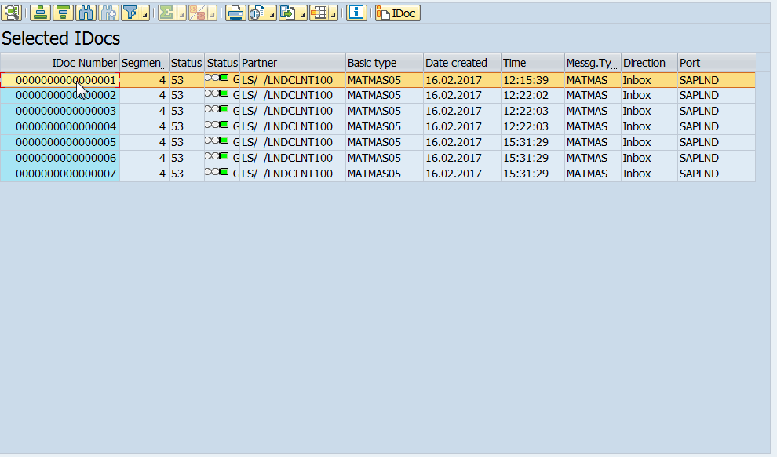

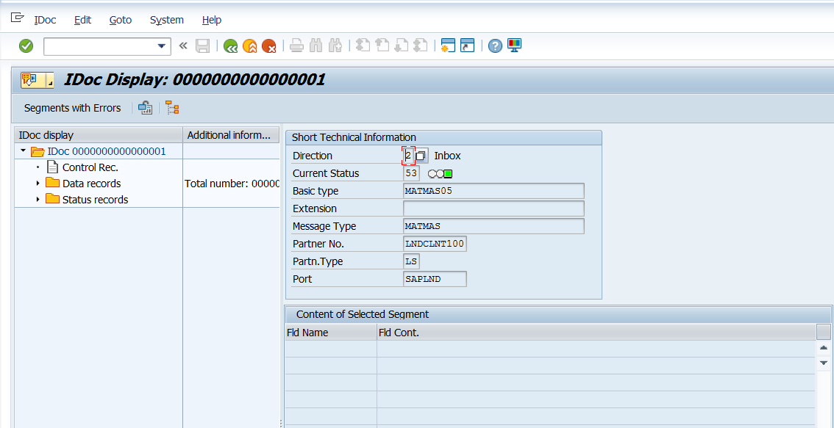

1. Client 200. SE11. See the contents or MARA table. Data added via client 100 is available in client 200.

